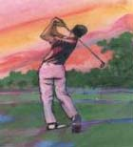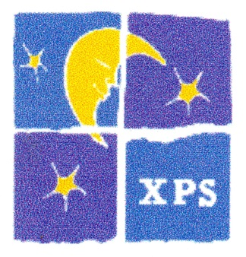
12th Annual Camp Sundown Classic Golf Tournament Copake Country Club Friday August 3, 2018
Sponsorship Opportunities
Celestial: $2500 Includes foursome, exclusive event signage, Signage, optimal placement, logo promotion on our website and link to your page for one year, inclusion in all promo materials and annual newletter and press release.
Lunar $1000 Includes one foursome, prominent signage, prominent placement on promotional materials, logo promoted on our website with hyperlink to yours for one year, inclusion in annual newsletter and press release.
Stellar $500 Includes two free golfers, signage, logo promotion on website for one year, promotion in press release and event materials.
Camper Sponsor $350 includes one free golfer, signage, company name on event materials
Green $250 Includes signage, company name on event materials
Tee $100 includes signage and name in event material
Other: Breakfast ($100) Cocktail Hour ($200) Lunch Shack ($250) Dinner ($200 or gifts in kind) Music (Gift in Kind) Raffle Prizes or Goody Bag items (Gift in Kind)
**************************************************************************
Company Sponsor___________________________________________________________
Contact Person ___________________________________________________________
Address ___________________________________________________________________
Phone ___________________________ Email_____________________________________
Sponsorship Level _________ Please make checks payable to Camp Sundown Sponsorship amount__________ and mail to:
Robert Preusser/ Camp Classic
790 Route 23
Craryville, NY 12521

